GoToWebinar Tips

The purpose of this tip sheet is to help you navigate the GoToWebinar technology for a successful interactive session.

How to Join

1. After you have registered for the Webinar, you will receive a confirmation email immediately. Also the day before and the hour before the session begins. If you do not, please check your Junk mailbox.

2. Click the link you will have received in your confirmation email.

Note: This link should not be shared with others; it is unique to you.

3. Choose one of the following audio options:

TO USE YOUR COMPUTER'S AUDIO: (Default setting)

When the webinar begins, you will be connected to audio using your computer's microphone and speakers (VoIP) by default.

--OR--

TO USE YOUR TELEPHONE (recommended unless you are completely confident in your computer’s audio set up):

If you prefer to use your phone, you must select "Telephone" after joining the webinar and call in using the numbers and access code provided. If you wish to speak when unmuted during the session, you must enter the Audio PIN that will be directly below the phone # and access code.

The option to choose between your computer’s audio and your telephone will be located on your control panel, which will be on the right side of your screen. Please see the image below. Note: The #’s in the image are for example purposes only and will be different in your session.

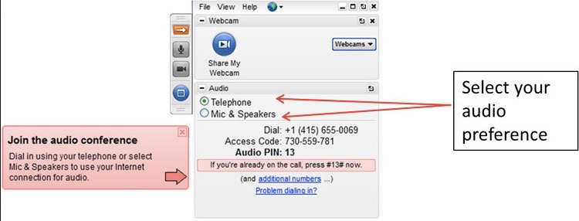

Click Here for a brief video showing what the GoToWebinar Telephone call in process looks like. The #’s entered in the video are for example purposes only and will be different during your session: Also, your Control Panel may look somewhat different depending on the operating system and browser you are using.

Note: You will enter the session in “Listen Only” mode. You will be able to speak and participate when unmuted by the Presenter.

Participating During The Session

You will be able to participate and interact with the Presenters and the other attendees in several ways.

1)Typing questions/comments into the “Questions” area on your Control Panel, as indicated in the image below. Presenters will see your Questions and either respond to them within the Question area or verbally during the session.

2)”Raising Your Hand” to be called upon and unmuted by the Presenter. This is done by clicking the Open Palm icon on your Control Panel, as indicated in the image below.

Note: Your Control Panel may look somewhat different, depending on what operating system and browser you are using.

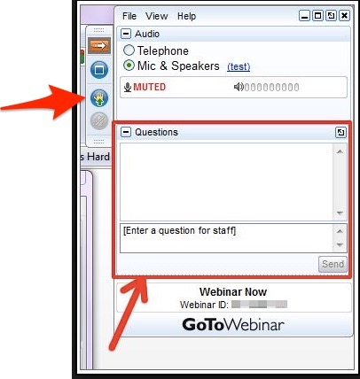

Audio/Participation Troubleshooting

Can’t be heard when unmuted:

Re-enter audio pin (if on telephone).
Toggle back and forth between Mic and Speakers and Telephone.
Try alternate audio device (landline vs cell phone).

Poor Audio Quality: (single caller)

Switch to a traditional phone and call in.
Check internet connection.
Leave and Rejoin the session.

System Requirements

The minimum system requirements for desktops/laptops needed to best facilitate a GoToWebinar session are:

Operating system | Mac OS X 10.6 (Snow Leopard)  Mac OS X 10.7 (Lion)  Linux / Ubuntu  Google Chrome OS (Chromebook)
Web Browser | Mozilla Firefox v34 or later  Google Chrome v39 or later
Internet connection | 1 Mbps or better (broadband recommended)  3G connection or better (WiFi recommended for VoIP audio) for Chromebooks
Software | None
Hardware | Microphone and speakers

Contact Terry@learninginaction.com or 508-212-8076 for further assistance.

