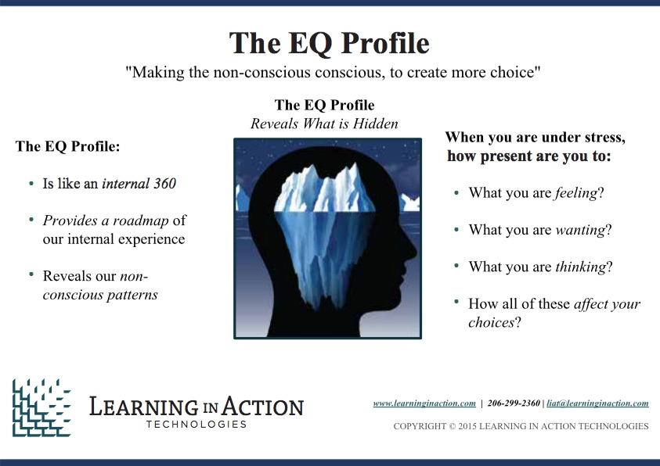

Go Deeper Faster with Clients Using The EQ Profile

As coaches, our primary aim is to help our clients deepen their learning, improve their performance, and enhance their lives. And often, the easiest way to do that is to help them see how they are getting in their own way. But that can be tough.

The EQ Profile: Helps Clients See Themselves

The EQ Profile makes nonconscious patterns conscious and provides clients with a view of their internal landscape under stress. It reveals what they are bringing to their relationships and how they might be blocking their own desired outcomes. And it gives them the gift of truly conscious choice in how they live their lives, both personally and professionally.

Coaches say the EQ Profile acts as an internal 360, providing their clients insight, awareness and feedback into what’s going on inside them. The EQ Profile quickly allows them to dive beneath the surface, dramatically reducing time wasted working at the surface.

EQ Profile Certification

Learning in Action holds two day training sessions with additional follow up virtual classes to take an intensive “deep dive” into the rich layers of understanding of how we are shaped and shape others in relationship and how EQ Profile can be used and interpreted to better understand that dynamic. The classes are a fun, collaborative learning experience. You will:

Learn the theoretical underpinnings of the EQ Profile and the unique design that allows it to capture the nonconscious patterns that can govern our lives and relationships

Explore EQ; how it’s developed and how it is captured by the EQ Profile.

Discover how to use the EQ Profile to deepen your relationships with your clients and help them move forward faster to achieve their goals.

Registration and Training Dates

Training Dates:

February 24-26, Bethesda, MD: Register HERE Price $1,999

March 16-18, Seattle, WA: Register HERE Price $1,999

April 13-15, Vancouver, BC: Register HERE Price $1,549

June 1-3, Seattle, WA: Register HERE Price $1,999

September 28-30, Seattle, WA: Register HERE Price $1,999

November 30-December 2, Seattle, WA:Register HERE Price $1,999

For more information, contact Jeannine Hall at Jeannine@learninginaction.com or call 206-299-2360

